Lab Exercise 10: Using DDL Statements to Create and Manage Tables

Consider you will have this following ERD for your database:

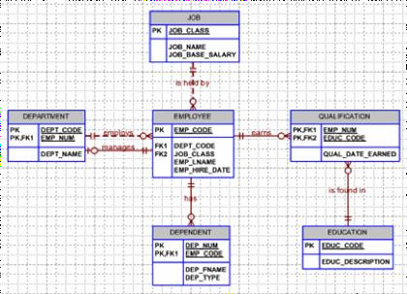

1. By using **DDL statement**s, create all tables for EMPLOYEE Schema above with all the constraints.

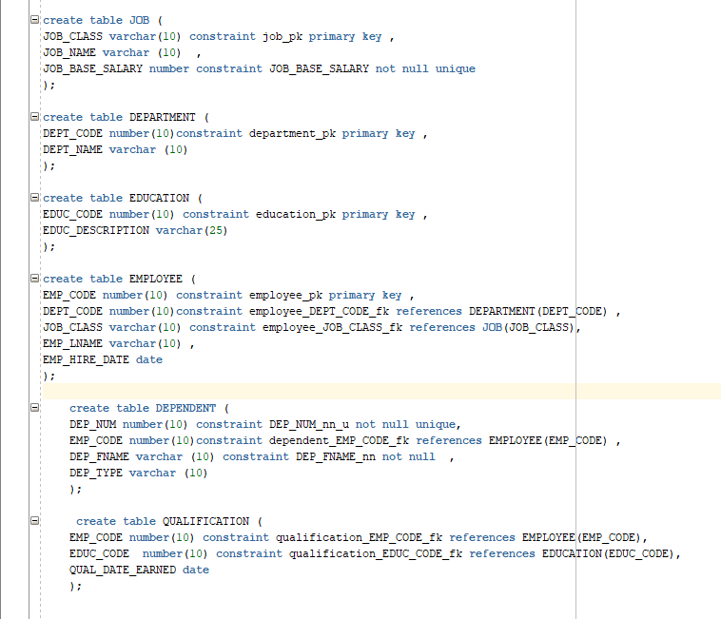

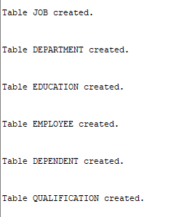

1. Alter table **DEPARTMENT** to read-only status.

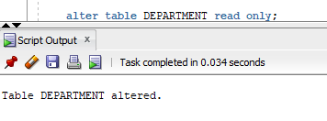

1. Alter table **DEPARTMENT** to read-write status.

